DUNLUCE GUIDE HOUSE BOOKING FORM
Name of Group
Details of Leader in charge of party
Name
Address
Tel Landline |  |  |  | Tel Mobile
E-mail
Preferred date of booking | From |  | To |  |  |  | Number of nights
Number of children | Female |  | Male |  |  |  | Total |  | £
Number of adults | Female |  | Male |  |  |  | Total |  | £
Service charge per group, per night £30.00 |  |  |  |  |  |  |  |  | £
Cleaning charge per group £60.00 |  |  |  |  |  |  |  |  | £
Total Cost |  |  |  |  |  |  |  |  | £
A non-refundable deposit of £100.00 (or full cost if less) must accompany this booking form to ensure your booking. Cheques made payable to DUNLUCE GUIDE HOUSE or via Bank Transfer (please request bank details).
The final balance is due 10 days prior to your arrival or the full cost at time of booking if less than 10 days. Any breakages/damage will be billed separately after your visit. Please also enclose with your booking form:
- Badge order form with separate cheque made payable to Dunluce Guide House if required
- 1 x A5 stamped envelope.
Signed: ______________________________________________________________________________

Please send completed booking form to: Jayne Johnston 159 Ballygowan Road, Hillsborough, BT26 6EG Tel: 028 9269 9747 /
07732 648079

CONFIRMATION
Name of Group
Name of Leader in Charge
Dates |  | From |  | To
Number of children | Female Male | Number of adults | Female Male |  | Total
Group Service Charge @ £30 per night Group Cleaning charge £60.00 |  |  |  |  | £
Total cost
Thank you for your booking and deposit which is now confirmed. Final balance of £ is due by
Arrival is after 4:00pm and Departure is by 12:00 noon. Please check prior to arrival to check if times can be altered to suit your needs.
We hope you have an enjoyable stay in Dunluce Guide House. Signed:_______________________________________________________________________________ Booking Secretary
 …………………………………………………………………………………………………………………………………………………………
FINAL BALANCE PAYMENT
Name of Group
Name of Leader in Charge
Dates |  | From |  | To
Number of children | Female Male | Number of adults | Female  Male |  | Total
Total | £ |  | £ |  | £
Total cost including Service Charge & Cleaning
Less deposit of £100.00 |  | Final Balance |  |  | £

I enclose cheque (made payable to DUNLUCE GUIDE HOUSE) for£ ______________ and a stamped addressed envelope for receipt.
Signed: ________________________________________________________ Leader in Charge
I understand any breakages/damage will be billed separately after my visit.

PLEASE ENSURE ALL PARTICIPANTS BRING THE FOLLOWING:
- Sleeping bag + pillow
- Fitted sheet + pillow case (the mattresses MUST be covered with a fitted sheet or similar)
- Towels & toiletries

THE LEADER IN CHARGE MUST PROVIDE THE FOLLOWING:
- First Aid Equipment
Note:
Any unused items (including dishcloths & tea towels must be taken home at the end of your visit.
- Washing and cleaning materials
- Toilet rolls and Kitchen roll
- Tea towels + dishcloths
- Black bin bags
- Small bin liners

Please note: Soft shoes MUST be worn at all time in the house. All outdoor shoes/boots & wet coats must be left in the BOOT ROOM.

Fire Appliances: There are extinguishers throughout the house and a fire blanket in the kitchen.

INSURANCE: Personal items are brought at OWN RISK and are NOT covered by the DGH Policy.

Arrival/Departure Times: To facilitate same day changeover you are asked to arrive after 4.00pm and depart by 12:00 noon. It may be possible to alter these times by prior arrangement. Please check with Jayne Johnston (07732648079) before you arrive.

PRE - VISIT FIRE POLICY

Name of Group ………………………………………………………………………………………..… Date ………………............…
Adopted by LMC January 2018 and Issued by and received by Booking Secretary. Reviewed due January 2020
Fire Regulations – The Management Committee of Dunluce Guide House aim to provide safe accommodation for adults and young persons with regard to fire safety.
A fire risk assessment has been carried out and safe procedures have been put in place to manage the risk of fire starting, spreading, and to provide safe means of evacuation in the event of a fire. It will be reviewed annually.
The Management Committee has a strict ‘No Smoking’ Policy both inside the house and within the grounds of the house which must be adhered to.
The fire alarm control panel for the alarm is found in the boot/laundry room. You should only need access to this if you trigger the alarm (by burning toast etc) to re-set when there is NO fire.
There are four fire exits (green running man) – main door, front door, dormitory door and kitchen door.
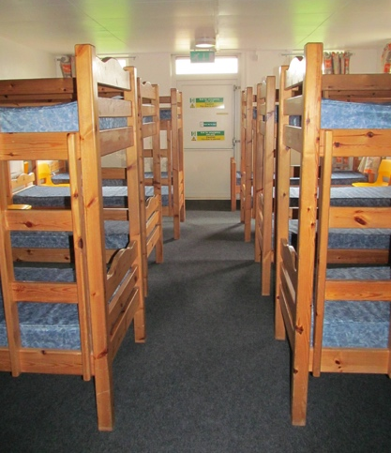
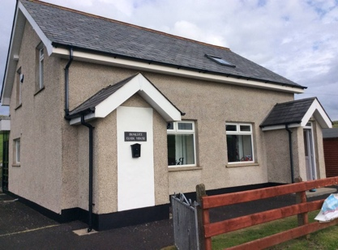

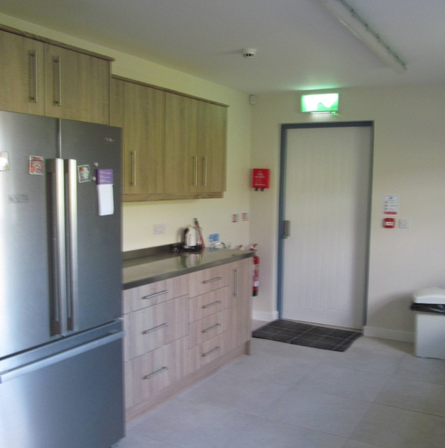

The assembly point is in the corner of the front grounds beyond the cabin and opposite the graveyard and signage is in place.

Please familiarise yourself and your party with these exits and assembly point as it is your responsibility to ensure that you can safely exit your party in an emergency. We highly recommend that you carry out a FIRE DRILL on arrival by completing the form below.
There are fire extinguishers throughout the building and a fire blanket in the kitchen. Please familiarise yourself with the position of the fire extinguishers.
It is recommended that leaders discourage the bringing of personal electrical appliances to the premises. However it is the leader’s responsibility to ensure that any such equipment is safe and unplugged at night and when leaving the house for outside activities.

Mobile phone chargers should NOT be left plugged in overnight.

On arrival an appropriate person should be identified and adults/leaders assigned to ensure all rooms (including toilets) are evacuated in case of fire.

------------------------------------------------------------------------------------------------------
As group leader I have read all the pre-visit information in relation to FIRE SAFETY. I agree to carry out FIRE EVACUATION PRACTICE (Fire Drill) with my group on arrival and record the date and time taken to evacuate building by detaching the Fire Drill Record below.

Signed: _____________________________________________ Date: ______________

--------------------------------------------------------------------------------------------------

FIRE DRILL RECORD
Name of Group: ___________________________________________________________________________________

Number in Group: Date of Fire Drill:

Time taken to evacuate building and assemble at assembly point for head count:

Signed: _____________________________________________________________ Date: _____________________ Group Leader
Please leave this record for Key Lady to file.

DUNLUCE GUIDE HOUSE
BADGE ORDER FORM
Send all orders to:
Booking Secretary
Mrs. Jayne Johnston
159 Ballygowan Road,
Hillsborough.
BT26 6EG.
028 92699747
Email: jayne.johnston2@live.co.uk

Quantity | Description | Unit Price | Total (£)
 | Dunluce Guide House Woven Badges | £1 each
 | Subtotal
 | Shipping & Handling (£1 per 20 badges)
 | Total Due
 | Cheques Payable to “Dunluce Guide House”

YOUR DETAILS
Name
Address (For shipping)
Unit/District/County
Phone Number
Email address

Thank you for your support
Keep up to date with us at www.facebook.com/dunluceguidehouse

